Inset maps enable multiple places to be shown in the same geographic data visualization.

R’s flexibility allows inset maps to be created in various ways, using different approaches and packages. However, the main idea stays the same: we need to create at least two maps: a larger one, called the main map, that shows the central story and a smaller one, called the inset map, that puts the main map in context.

This blog post shows how to create inset maps with **ggplot2** for visualization.

The approach also uses the **sf** package for spatial data reading and handling, **cowplot** to arrange inset maps, and **rcartocolor** for additional color palettes.

To reproduce the results on your own computer, after installing them, these packages can be attached as follows:

library(sf) library(ggplot2) library(cowplot) library(rcartocolor)

# Basic inset map

Let’s start by creating a basic inset map.

## Data preparation

The first step is to read and prepare the data we want to visualize.

We use the us_states data from the **spData** package as the source of the inset map, and

north_carolina from the **sf** package as the source of the main map.

library(spData)

data("us_states", package = "spData")

north_carolina = read_sf(system.file("shape/nc.shp", package = "sf"))

Both objects should have the same coordinate reference system (crs).

Here, we use crs = 2163, which represents the US National Atlas Equal Area projection.

us_states_2163 = st_transform(us_states, crs = 2163) north_carolina_2163 = st_transform(north_carolina, crs = 2163)

We also need to have the borders of the area we want to highlight (use in the main map). This can be done by extracting the bounding box of our north_carolina_2163 object.

north_carolina_2163_bb = st_as_sfc(st_bbox(north_carolina_2163))

## Maps creation

The second step is to create both inset and main maps independently.

The inset map should show the context (larger area) and highlight the area of interest.

ggm1 = ggplot() +

geom_sf(data = us_states_2163, fill = "white") +

geom_sf(data = north_carolina_2163_bb, fill = NA, color = "red", size = 1.2) +

theme_void() ggm1

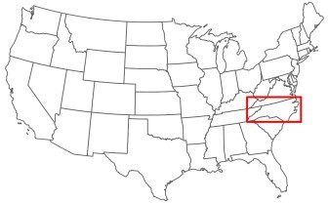

The main map’s role is to tell the story.

Here we show the number of births between 1974 and 1978 in the North Carolina counties (the BIR74

variable) using the Mint color palette from the **rcartocolor** palette.

We also customize the legend position and size – this way, the legend is a part of the map, instead of being somewhere outside the map frame.

ggm2 = ggplot() +

geom_sf(data = north_carolina_2163, aes(fill = BIR74)) + scale_fill_carto_c(palette = "Mint") +

theme_void() +

theme(legend.position = c(0.4, 0.05), legend.direction = "horizontal", legend.key.width = unit(10, "mm"))

ggm2

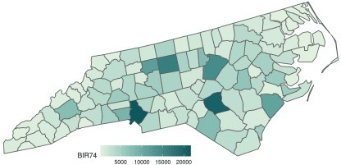

## Maps joining

The final step is to join two maps.

This can be done using functions from the **cowplot** package.

We create an empty ggplot layer using ggdraw(), fill it with out main map (draw_plot(ggm2)), and add an inset map by specifing its position and size:

gg_inset_map1 = ggdraw() + draw_plot(ggm2) +

draw_plot(ggm1, x = 0.05, y = 0.65, width = 0.3, height = 0.3) gg_inset_map1

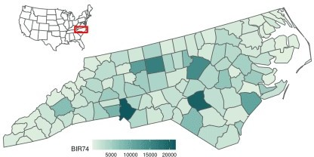

The final map can be saved using the ggsave() function.

ggsave(filename = "01_gg_inset_map.png", plot = gg_inset_map1,

width = 8,

height = 4,

dpi = 150)

# Advanced inset map

Let’s expand the idea of the inset map in **ggplot2** based on the previous example.

## Data preparation

This map will use the US states borders (states()) as the source of the inset map and the Kentucky Senate legislative districts (state_legislative_districts()) as the main map.

library(tigris)

us_states = states(cb = FALSE, class = "sf")

ky_districts = state_legislative_districts("KY", house = "upper",

cb = FALSE, class = "sf")

The states() function, in addition to the 50 states, also returns the District of Columbia, Puerto Rico, American Samoa, the Commonwealth of the Northern Mariana Islands, Guam, and the US Virgin Islands. For our purpose, we are interested in the continental 48 states and the District of Columbia only; therefore, we remove the rest of the divisions using subset().

us_states = subset(us_states,

!NAME %in% c(

"United States Virgin Islands",

"Commonwealth of the Northern Mariana Islands", "Guam",

"American Samoa", "Puerto Rico", "Alaska", "Hawaii"

))

The same as in the example above, we transform both objects to have the same projection.

ky_districts_2163 = st_transform(ky_districts, crs = 2163) us_states_2163 = st_transform(us_states, crs = 2163)

We also extract the bounding box of the main object here.

However, instead of using it directly, we add a buffer of 10,000 meters around it. This output will be handy in both inset and main maps.

ky_districts_2163_bb = st_as_sfc(st_bbox(ky_districts_2163)) ky_districts_2163_bb = st_buffer(ky_districts_2163_bb, dist = 10000)

The ky_districts_2163 object does not have any interesting variables to visualize, so we create some random values here.

However, we could also join the districts’ data with another dataset in this step.

ky_districts_2163$values = runif(nrow(ky_districts_2163))

## Map creation

The inset map should be as clear and simple as possible.

ggm3 = ggplot() +

geom_sf(data = us_states_2163, fill = "white", size = 0.2) +

geom_sf(data = ky_districts_2163_bb, fill = NA, color = "blue", size = 1.2) + theme_void()

ggm3

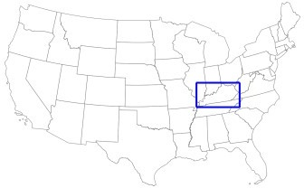

On the other hand, the main map looks better when we provide some additional context to our data. One of the ways to achieve it is to add the borders of the neighboring states.

Importantly, we also need to limit the extent of our main map to the range of the frame in the inset map. This can be done with the coord_sf() function.

ggm4 = ggplot() +

geom_sf(data = us_states_2163, fill = "#F5F5DC") + geom_sf(data = ky_districts_2163, aes(fill = values)) + scale_fill_carto_c(palette = "Sunset") +

theme_void() +

theme(legend.position = c(0.5, 0.07), legend.direction = "horizontal", legend.key.width = unit(10, "mm"),

plot.background = element_rect(fill = "#BFD5E3")) + coord_sf(xlim = st_bbox(ky_districts_2163_bb)[c(1, 3)],

ylim = st_bbox(ky_districts_2163_bb)[c(2, 4)])

ggm4

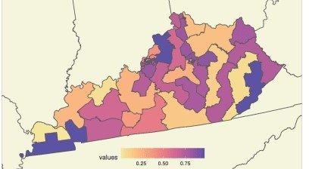

Finally, we draw two maps together, trying to find the best location and size for the inset map.

gg_inset_map2 = ggdraw() + draw_plot(ggm4) +

draw_plot(ggm3, x = 0.02, y = 0.65, width = 0.35, height = 0.35)

gg_inset_map2

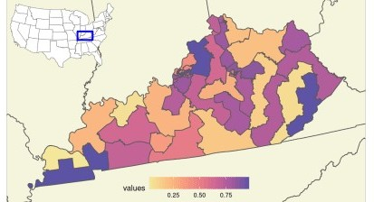

The final map can be saved using the ggsave() function.

ggsave(filename = "02_gg_inset_map.png", plot = gg_inset_map2,

width = 7.05,

height = 4,

dpi = 150)

# Summary

The above examples can be adjusted to any spatial data and location.

It is also possible to put more context on the map, including adding main cities’ names, neighboring states’ names, and annotations (using geom_text(), geom_label()).

The main map can also be enhanced with the north arrow and scale bar using the **ggsn** package.